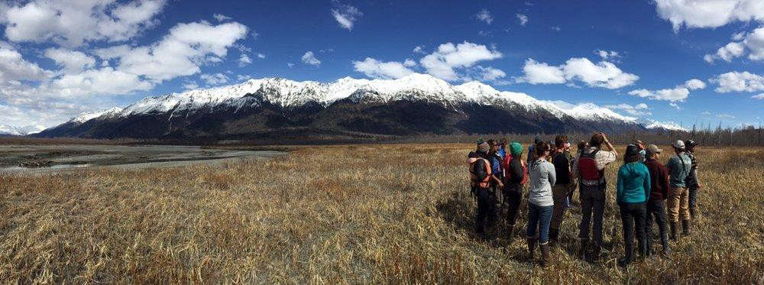

ALASKA SEMINAR: ENVIRONMENTAL AND CULTURAL SUSTAINABILITY

Lead Instructor: Professor Scott Ramsey, PhD
Contact Information: Email- scottakguide@gmail.com, Phone- 907-303-3697(c)
Website: www.alaskaoss.com

Course Description:

This unique interdisciplinary course focuses on the distinctive and dramatic landscape of Southeast Alaska to illustrate the interconnectedness between the major forces that have shaped our planet and how its inhabitants live their lives. The emphasis of this course is to foster students’ awareness of complex relationships that exist throughout the natural world and how they interact to have economic, social, cultural, and philosophical implications.

This is a place-based, service-learning focused experience taking place in Alaska, which centers ecological literacy, cultural resilience, and sustainability. It is designed for students who wish to experience and gain an understanding of some of Alaska’s unique wilderness environments and their significance to Indigenous and contemporary society. The educational setting for much of this course will be in the field and thus experiential in nature.

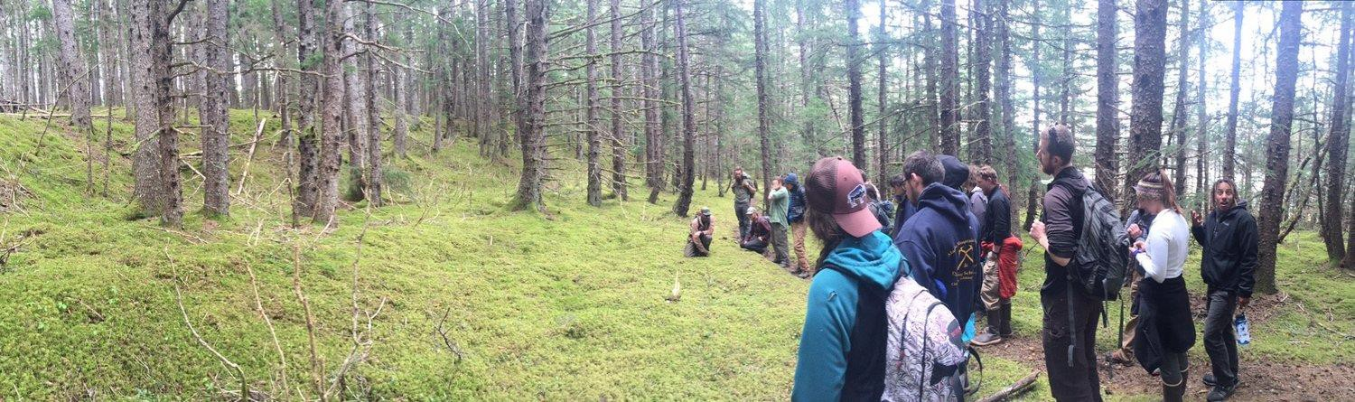

Learning Outcomes:

By combining classroom sessions, service-learning projects, and experiential opportunities, students are inspired to take full advantage of this amazing living laboratory to root their understanding. For example, students will conceptualize the erosive powers and the workings of glaciers by walking near glaciers, traversing their deltas, and floating on water from these frozen rivers of ice. From these hands-on experiences, students will gain an intimate understanding of the natural phenomena, will be better prepared to grasp the connections between melting glaciers and changing climate, and will be able to reflect on the impacts of these actions on the surrounding ecology and culture.

- Students will develop an understanding of the natural history of Southeast Alaska and be able to explain a basic comprehension of ecology and geology principles.
- By examining the major forces that have shaped Southeast Alaska, students will cultivate interpretation skills that will promote identifying the interconnectedness between the natural history of this area and its economic, cultural, and social impact.
- Students will be able to identify the indigenous people of Southeast Alaska and will learn their way of life and how this traditional ecological knowledge provides insight into concepts of sustainability.
- Students will be able to demonstrate evidence of climate change in this area and its ecological and cultural impact. Through reflection, students will be able to apply these concepts to their own part of the world.
- Through service project, students will deepen their sense of place and foster a sense of reciprocity by giving back to the community.

The Alaska Outdoor Science School Experience:
Alaska Seminar- Cultural and Ecological Sustainability
Draft Itinerary
Day 1: _________________________________________________________
Arrive Juneau
Introduction and Orientation
Lodging at Eagle Creek, Juneau
Day 2: ___________________________________________________________________
Classroom Session: Glaciation
Field session: Glacier Hike
Lodging at Eagle Creek, Juneau
Day 3: _______________________________________________________________________
Ferry Ride Exploration of the Scenic Lynn Fjord
Field session: Tide Pool Exploration
History of Haines and Orientation- Sheldon Museum Cultural Center
Stay in Haines
Day 4: _____________________________________________________________________
Classroom Session -Geology
Field session-Glaciers and Geology Hike to Chilkat State Park
Stay in Haines
Day 5: ___________________________________________________________________
Classroom Session – Marine Ecology and Salmon Biology
Field session: Salmon Expedition/Trapping
Stay in Haines
Day 6: _______________________________________________________________________
Classroom Session - Ecologic Literacy and Climate Change
Field session: Ecology Hike to Jones Point/ Tree Coring Session
Stay in Haines
Day 7: _______________________________________________________________________
Classroom Session- Traditional Ecological Knowledge- with Tlingit Elders
Field session: Field Trip to Jilkaat Kwan Heritage Center/
Stay in Haines
Day 8 and 9: _______________________________________________________________________
Field Session- Service Learning Project
Overnight Rafting Field Trip- Exploration and Synthesis
Stay on the River Day 8/ Stay in Haines Day 9
Day 10: _____________________________________________________________________
Classroom Session - Ways of Knowing/ Closing Ceremony
Ferry Ride Exploration of the Lynn Fjord to Juneau
Stay in Juneau
Day 11: _____________________________________________________________________
Travel Day

***Please note that this schedule is tentative.

We may adjust it according to what best suits our class in response to changes in the weather, availability of guides, etc.

